Validation and Correction of Protein Structural Models
Refinement of the crystal structure of Transthyretin (PDB: 1TTA)
Inna Kucherova

Part I: Structure Quality & Metadata

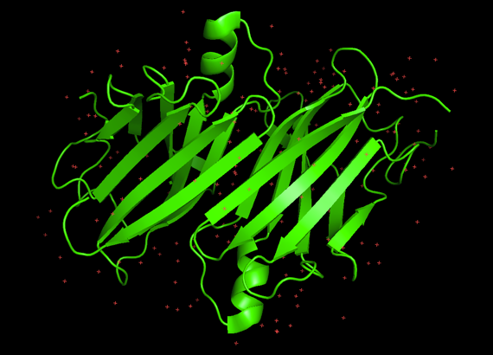
PDB Information
- PDB ID: 1TTA
- Title: THE X-RAY CRYSTAL STRUCTURE REFINEMENTS OF NORMAL HUMAN TRANSTHYRETIN AND THE AMYLOIDOGENIC VAL30MET VARIANT TO 1.7 ANGSTROMS RESOLUTION
- Organism: Homo sapiens
- Year: 1992
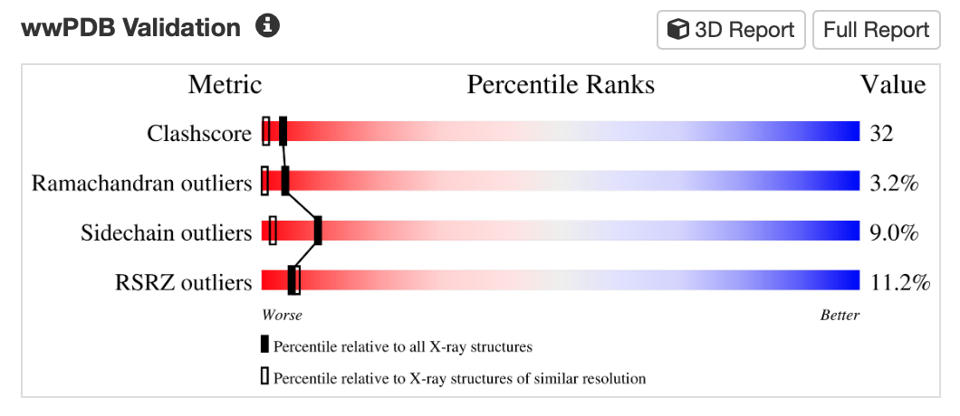
- Study: https://doi.org/10.2210/pdb1TTA/pdb
- Methodological Quality
- PDB ID: 1TTA
- Method: X-RAY DIFFRACTION
- Resolution: 1.70 Å
- R-values:
              - R-Value Work: 0.170
              - R-Value Observed: 0.168
Transthyretin (1TTA) – a homotetrameric protein, which plays crucial role in amyloidosis. Despitte high resolution in 1.70 Å, this protein shows poor metrics in compare to structures with similar resolution. All key indicators are in red zone – Worse – which indicates low geometric quality of the protein model.
Clashscore=32 is extremely high value, which means that structure is physically overcrowed and the atoms overlap. For high quality structures this value usually <10.
Ramachadran outliers=3.2% means that backbone of protein is broken or twisted to unnatural angles. A value <0.2% is normal.
Sidechain outliers=9.0% means that side chains are modelled incorrectly. Its can be result of automated modelling without verification.
RSRZ outliers=11.2% means that significant number of atoms located in regions with no electron density or shifted.
This values confirms that 1TTA structure requires refinancing to meet modern quality standarts.
- Visual analysis of density maps
Whtn overlying difference electron dencity maps Fo-Fe, a large amount of noise was observed:
- Red coluds (negative) indicates that atoms in the model were located not in right place, eg steric conflicts or false water molecules
- Green clouds (positive) indicates uncounted electron density where atoms absent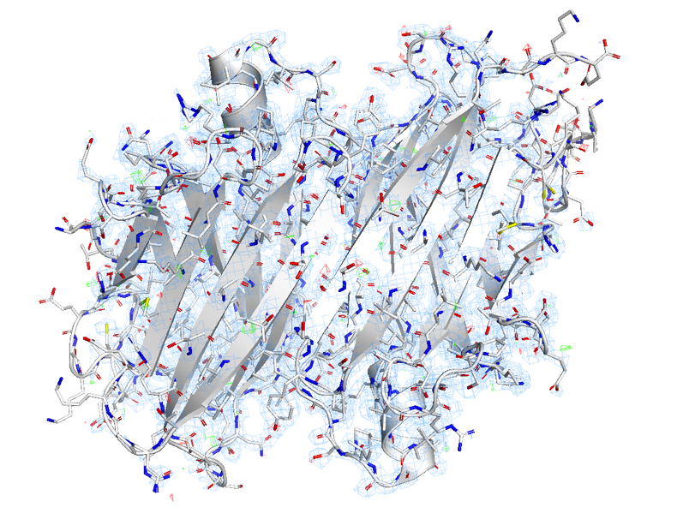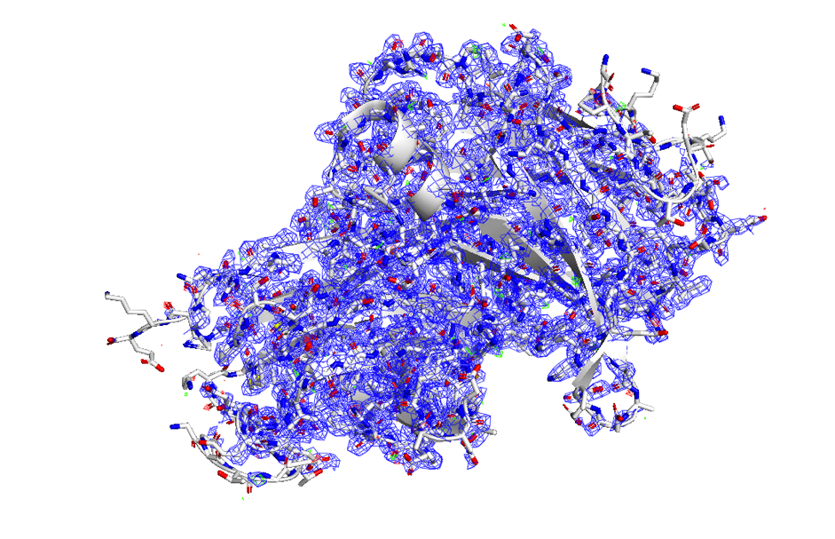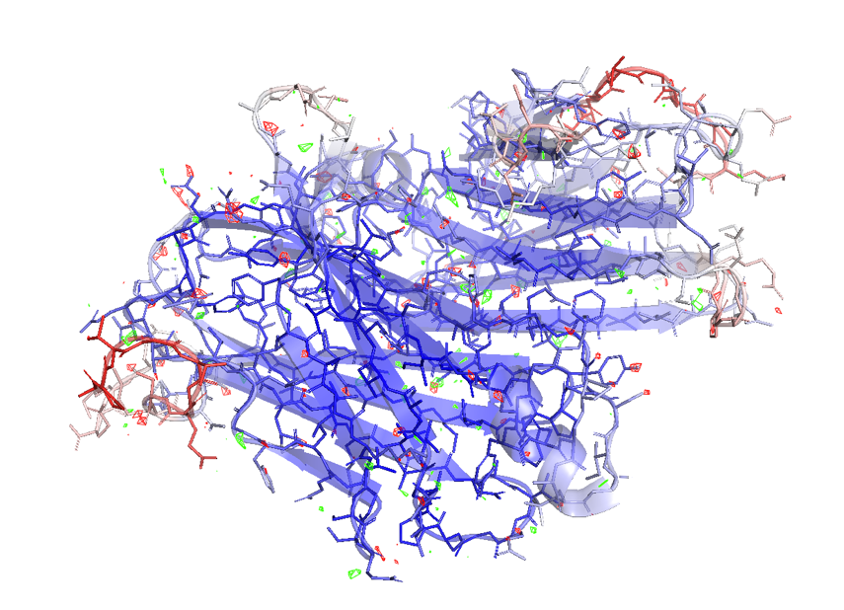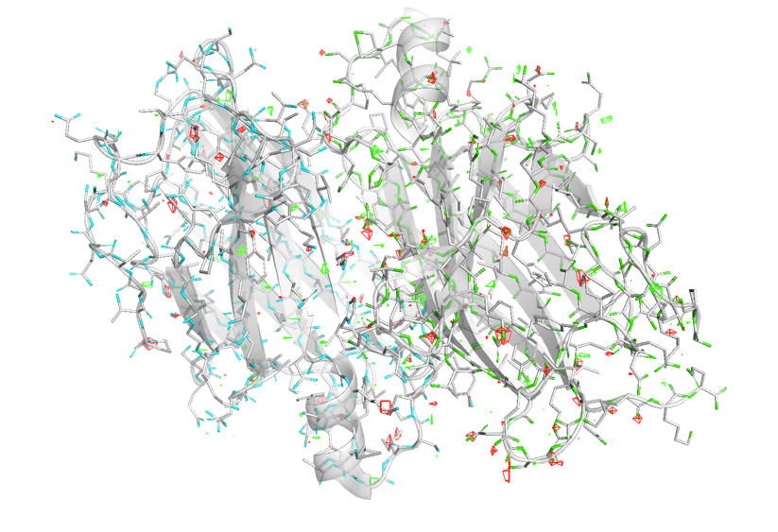
The core (rigid) part of tetramere has a clear density which allows to determine position of atoms clearly. However, peripheral (flexible) parts contain a lot of noise and density gaps which correlates with the main localization geometric errors (outliers).

Part II: Diagnostics using MolProbity

Diagnostics using MolProbility confirmed problematic protein geometry.
Clashscore: 16.29 (31th percentile) – for every 1000 atoms there are more than 16 serious claches with resolution >0.4A.
Rotamer outliers: 9.65% (22 residues) -- ~one in ten side chains in energetically forbidden conformation
Critical contacts: physically impossible interaction >1.0A, eg side chain Thr3 and main chain Glu62 (1.07A), or intrachain conflict in B-chain between Pro2 and Ser50 (1.096A).
Also, a significant portion of conflicts (10.75%) belonged to protein-water interactions, which indicates that automated water picking didn’t account vn der Waals radii.
Moreover, torsion angles analysis showed 8 residues in Ramachadran map forbidden zone. So, protein backbone unnatural twisted. This errors often located in flexible loops or C/N-terminus with blurred electron density. So, low MolProbity score=2.92 places 1TTA structure to 4th percentile (96$ of structures are better).
Almost 10% of all side chains are poor rotamers, eg B-chain has 4 outliers in a row – 80-86 residues region – Lys80, Leu82, Ser85, Pro86.
In addition, this structure has problems with bond lengths (1.13%) and angles (2.10%) – 23 covalent bonds deviate, and 58 angles have unceptapble values.
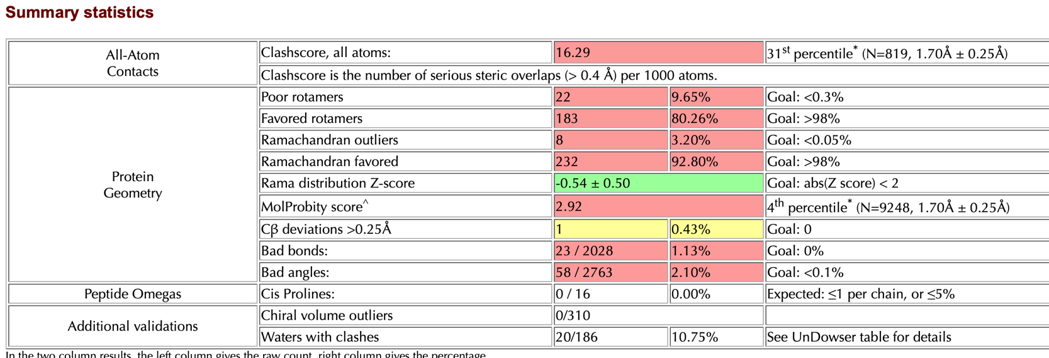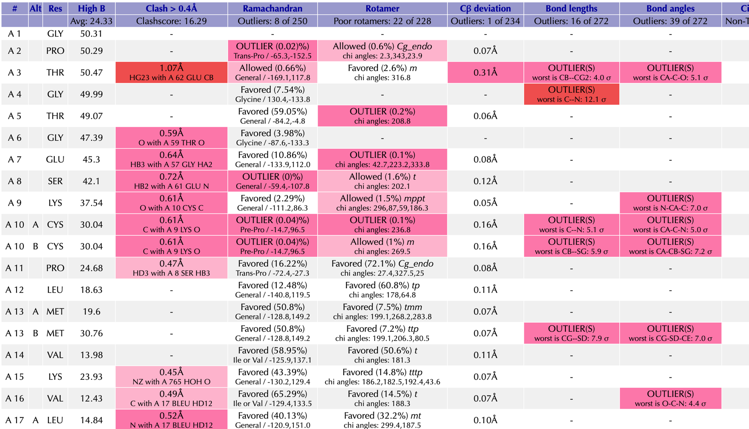
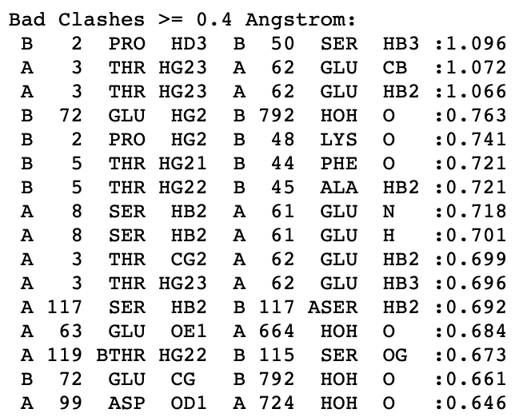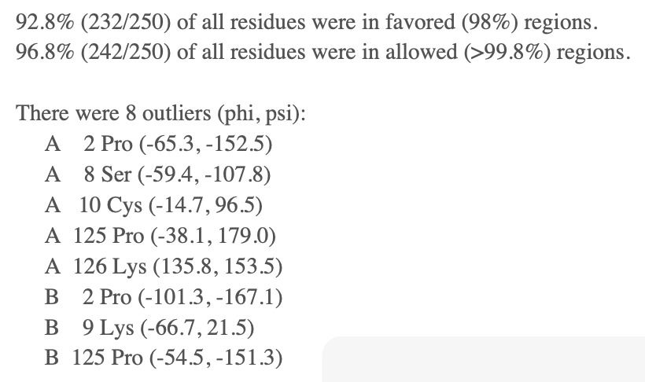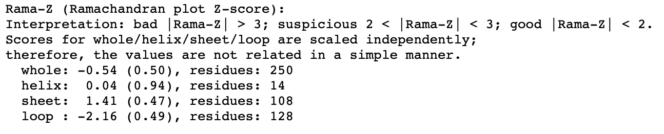
Part III: Refinement & Correction (PyMOL)
  - Successful corrections
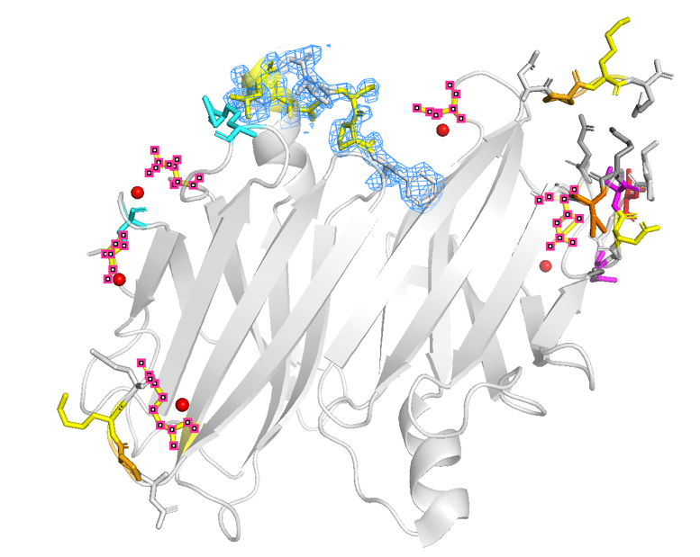
- N-terminal conflict on chain A
Thr3 had critical overlap with main helix, Thr5 was a rotamer outlier. Changing rotation of Thr3 allowed side group look toward solvent, eliminating 1.07A conflict. Thr5 was fitted to 2Fo-Fc map (red and violet residues).
- Loop 80-87 optimization on chain B
Cluster of errors included Lys80, Leu82, Ser85 and Pro86. Correction of some outliers (unfortunately, I don’t remember which of them). There was some changes due to breaking the structure during rotations of residues (yellow sticks with blue density map).
- Artifact water molecules, eg HOH792, created fantom conflicts with Glu72 and Asp74. Removal of 6 water molecules reduced water with clasher count from 20 to 14 (red balls).
  - Trial and error corrections
Important note that not all corrections were successful, some interventions leads to worse statistics, so changes were reversed. Eg, Pro2 and Ser50 1.096A conflict by rotating rotamers. But clashscore rose to 16.03 after that, and number of broken bonds increased to 24 too. Its can be caused by rigid prolin ring which doesn’t allow freely angles. So, changes was cancelled to keep structural integrity.
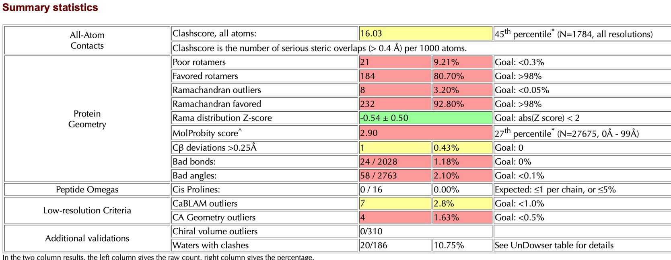
  - Results
As result, it was possible to achieve some improvement of 1TTA quality. Quantative indicators showed transition from low quality (31st percentile) to above average (53rd percentile).
Metric | Start value | Final value | Interpretation
Clashscore | 16.29 | 14.22 | ▼ reduction of steric strain
Percentile Rank | 31st | 53rd | ▲ structure is better than 53% of other structures with similar resolution
Poor Rotamers | 22 (9.65%) | 20 (8.77%) | ▼ local geometry was corrected
Waters with clashes | 20 | 14 | ▼ hydration level optimized, artifact water removed
MolProbity Score | 2.92 | 2.83 | ▼ overal quality score improvement

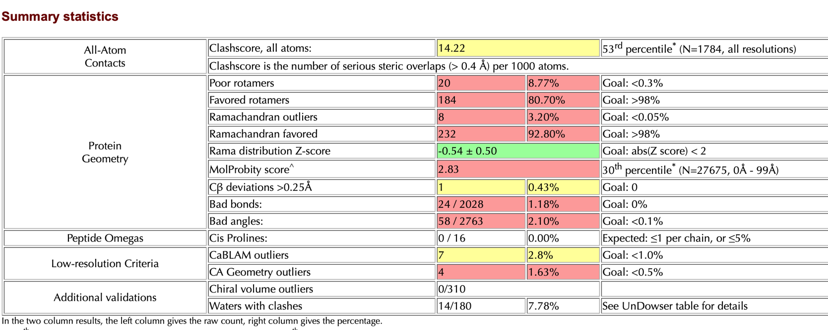

  - Limitations
Despite on some success during refining of 1TTA protein, there are some clear limitations that prevented to achieve 90th percentile:
- Backbone strain issue: Ramachandran outliers (8) and bad bonds (24) remains high, due to PyMol Mutagenesis wizard which can change only side chains (rotaners), but not main chain.
- Local optimum: correcting rotamers often led to domino effect – when corrected one, other conflict was created.
- Symmetry: due to tetramer structure of protein, errors in chain A mirrored to C, but here I considered only on chains A and B, and not duplicated changes to C and D chains.

Conclusions
Initial structure contained a number of steric conflicts, rotamer anomalities and water artefacts which typical for old models without careful verification.
Eletron density visualization allowed to identify and fix critical false configurations (eg Thr3), with high clashscore.
Cleaning the structure from false-positive waters is an effective and quick metrhod to improve statistic without affecting protein structure.
Obtained model with clashscore=14.22 is suitable for further usage, but needed to achieve perfect geometry (<5.0) – so, real-space refinement in Coot/Phenix needed to move main chain.

